Exp.No:21
21. Perform Sharpening of Image using Laplacian mask implemented with an extension of diagonal neighbours,
Aim
To sharpen an image using a Laplacian mask with diagonal neighbors in OpenCV.
Procedure
- Start the program.
- Import the OpenCV and NumPy libraries.
- Read the input image (BMW.jpg).
- Check whether the image is loaded.
- Define the Laplacian mask with diagonal neighbors.
- Apply the mask using cv2.filter2D().
- Subtract the filtered image from the original image.
- Display the original and sharpened images.
- Save the sharpened image.
- Stop the program.
Program:
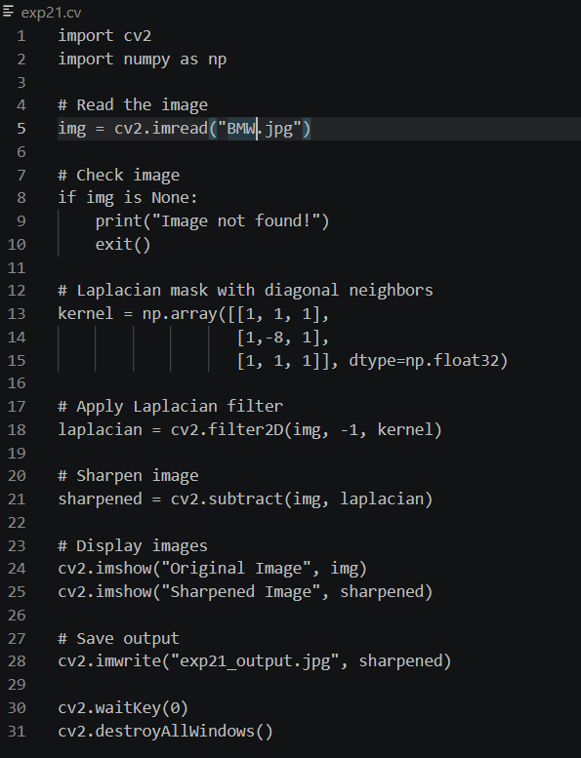
Input:
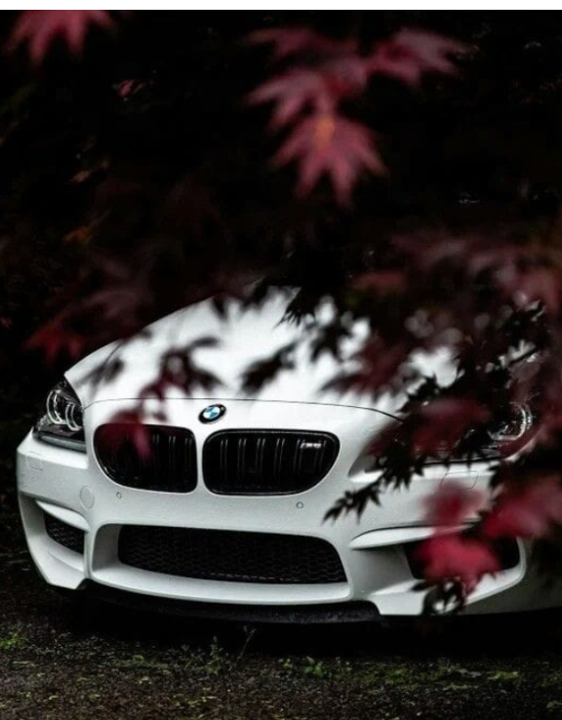
Output:
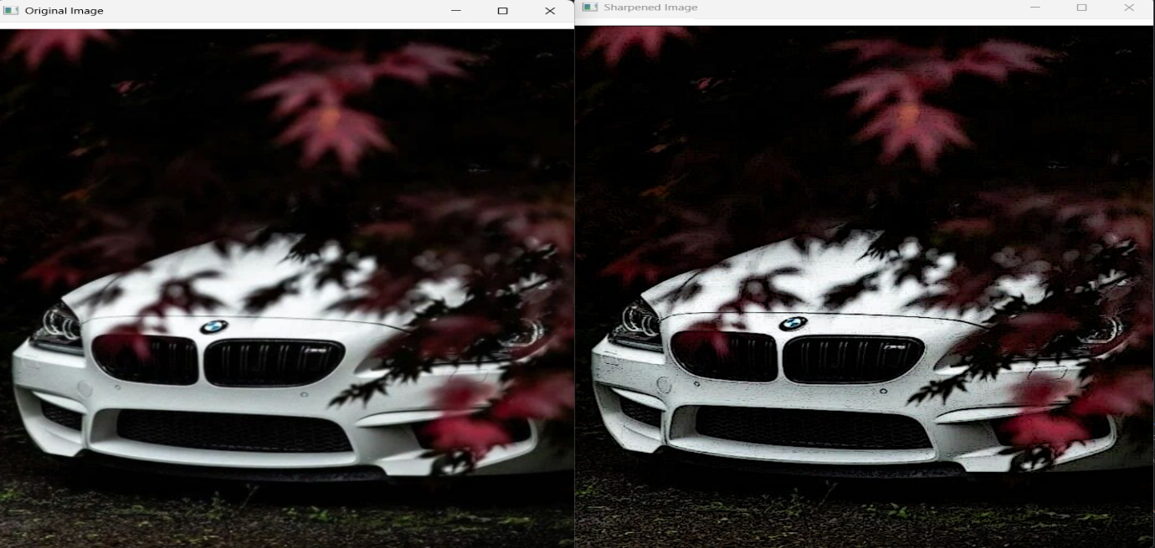
Result:
The image was successfully sharpened using the Laplacian mask with diagonal neighbours, and the sharpened image was displayed and saved.

